Project Design Phase-II
Technology Stack (Architecture & Stack)

Date | 26 June 2026
Team ID | Solo
Project Name | ShopEZ - E-Commerce Application
Maximum Marks | 4 Marks

Technical Architecture:
The Deliverable shall include the architectural diagram as below and the information as per the table1 & table 2

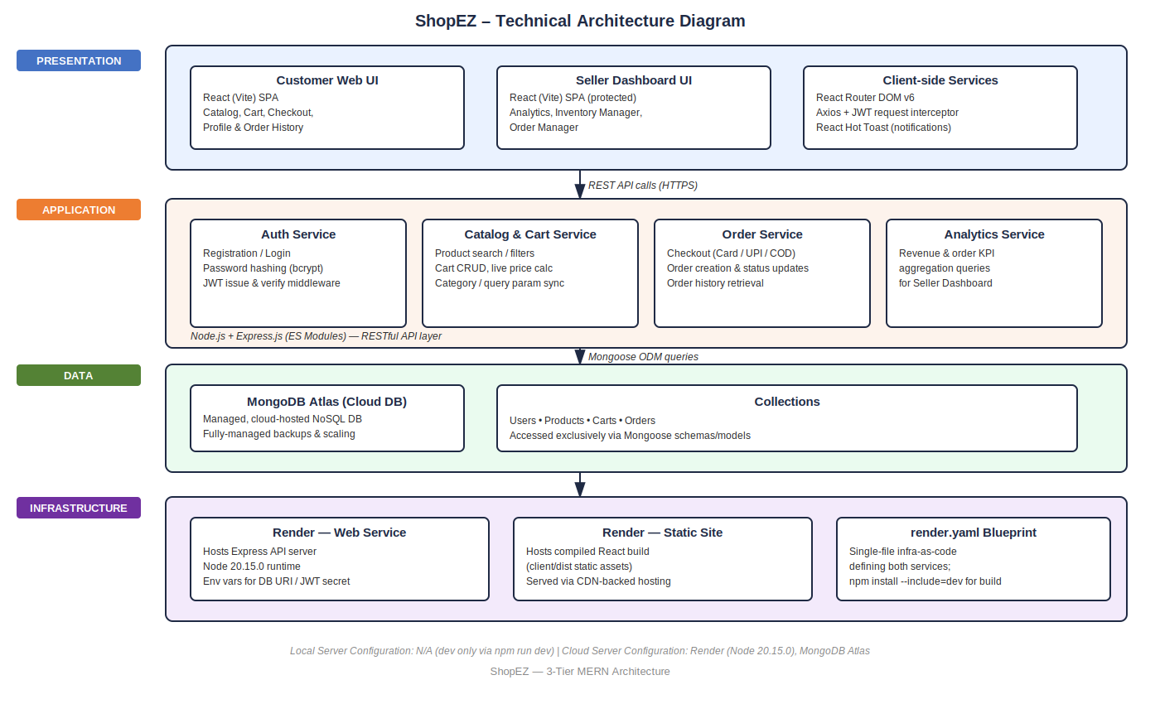

Table-1 : Components & Technologies:
S.No | Component | Description | Technology
 | User Interface | Web UI for customers to browse/shop and for sellers to manage their store | React (Vite), React Router DOM v6, React Icons, React Hot Toast
 | Application Logic-1 | Core business logic — auth, catalog, cart, checkout, order processing | Node.js, Express.js (ES Modules)
 | Application Logic-2 | Seller-side logic — inventory CRUD and order/status management | Node.js, Express.js REST controllers
 | Application Logic-3 | Seller analytics logic — aggregating revenue and order counts for KPI cards | Express.js + MongoDB aggregation via Mongoose
 | Cloud Database | Managed, cloud-hosted database service | MongoDB Atlas
 | File Storage | N/A for current scope (no dedicated file/image upload service in use) | Not applicable / Local filesystem (static assets)
 | External API-1 | Not applicable — no external API dependency in current scope | Not applicable
 | External API-2 | Not applicable — no external API dependency in current scope | Not applicable
 | Machine Learning Model | Not applicable — no ML model used in current scope | Not applicable
 | Infrastructure (Server / Cloud) | Application deployed entirely on cloud, no local server dependency. Local Server Configuration: N/A (development only, via npm run dev). Cloud Server Configuration: Render web service (Node 20.15.0) running the Express server + static site for the React build | Render (Cloud PaaS), unified render.yaml blueprint

Table-2: Application Characteristics:
S.No | Characteristics | Description | Technology
 | Open-Source Frameworks | Frontend and backend both built entirely on open-source frameworks | React, Express.js, Mongoose, Node.js
 | Security Implementations | Stateless authentication with signed tokens; passwords never stored in plain text; secrets excluded from version control; purged exposed credentials from Git history | JWT (JSON Web Tokens), bcrypt password hashing, .gitignore for .env secrets
 | Scalable Architecture | 3-tier architecture (presentation, application, data) with a clear separation between client/ and server/, allowing each layer to scale or be redeployed independently | 3-tier MERN architecture (React – Express – MongoD
 | Availability | Single-blueprint deployment keeps client and server in sync and simplifies redeploys; MongoDB Atlas provides managed uptime/replication for the database layer | Render unified deployment + MongoDB Atlas managed hosting
 | Performance | Vite-based build produces optimized, minified static assets for fast load times; Axios interceptor avoids redundant auth calls by reusing the stored JWT; Mongoose queries are scoped/indexed on key fields (e.g., category, order status) for fast catalog and order lookup | Vite build optimization, Axios request interceptors, MongoDB indexing via Mongoose

